Exercise 7

React Hook, Props & Conditional Rendering

**Implement the following instructions using the different React features and concepts.**

**Part 1 – Bootstrap, CSS and creating components.**

1. Create a React app **ex7**.
2. Import the Bootstrap library.
3. Import React router dom library.
4. Update the App.js component to create the Grid. Use Bootstrap classes to create the following wireframe.

|  |
| --- |
| (Header Component) |
| Main  (Home,ManageStudent, SearchStudent) will be rendered dynamically based on the Routes |
| (Footer Component) |

1. Create a folder named **Components** and create the following components inside the created folder. Refer to the screenshots for the content for each component.
   1. **Home –** The component should display the banner.jpg picture



* 1. **ManageStudent**
* Create an array that initializes names of students.

STUDENTS =["Ali", "John", "Asma"]

* Display these names when the page renders.
* Implement the appropriate codes to add the new student to the array when the user clicks the **"Add Student"** button and display the newly added student.
* Implement the appropriate codes to delete a student from the array when the user clicks the **"Delete"** button and display the updated student array after deletion.

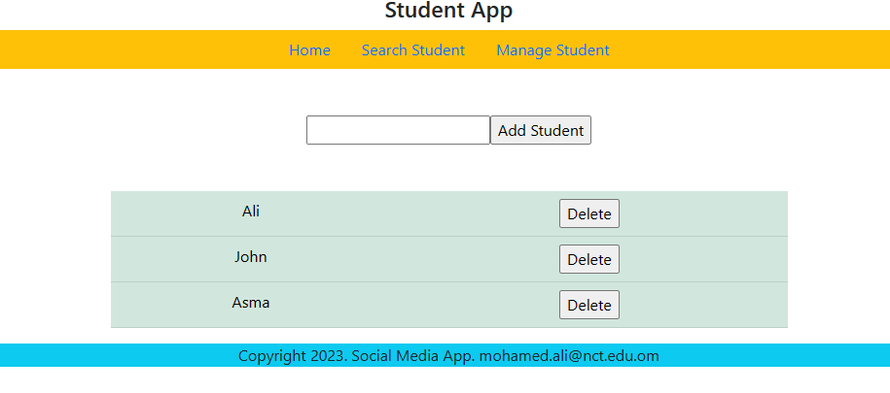

* 1. **SearchStudent -** In the **SearchStudent** component:
  + Create state variable **studentId** using the **useState** hook to store the user input.
  + Call the component **DisplayItem** and pass the parameter **studentId.**
  + The component **DisplayItem** should take the parameter **studentId** from the parent component **SearchStudent**. And it should search and display the details from the **StudentsData** array. The **StudentsData** array should be imported in the component.
  + The component can use filter and map method to display the student details.

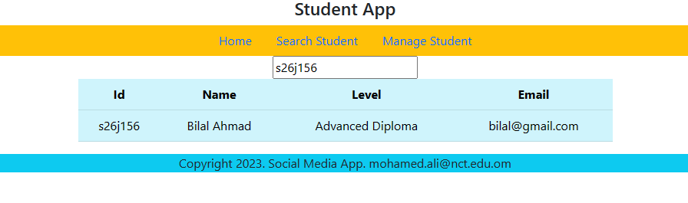

* 1. **Header –** Import the header component which is available in the work file folder. You can find the routes for each component.



* 1. **Footer -** Import the header component which is available in the work file folder.



1. Your **index.js** should render only the App component.
2. Render the components on the specified grids.

|  |
| --- |
| (**Header** Component) |
| Main  (**Home,ManageStudent, SearchStudent**) will be rendered dynamically based on the Routes |
| (**Footer** Component) |

1. **Creating Routes**
2. Use the React Router to create routes to the three components.
   1. **/** 🡪 render the **Home** component
   2. **/search** 🡪 render the **SearchStudent** component
   3. **/manage** 🡪 render the **ManageStudent** component
3. Update the **nav** bar in the header components to link to the created routes apply necessary bootstrap classes.